Pizza Sales SQL queries

- KPIS
- Total Revenue
select sum(total_price) as total_revenue from sales;
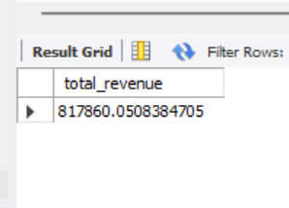

- Total Orders
select count(distinct order_id) as Total_Orders from sales;
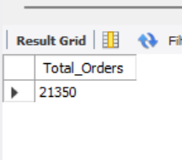

- Average Order Value
select sum(total_price) / count(distinct order_id) as avg_order_value from sales;
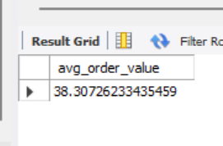

- Total Pizza Sold
select sum(quantity) as Total_Pizza_sold from sales;
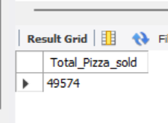

- Average Pizza Sold per Order
select sum(quantity) / count(distinct order_id) as avg_pizza_sold from sales;
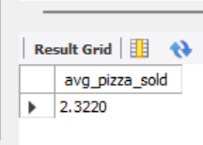

- Charts
- Daily Trend for Total Orders
select dayname(order_date) as order_day, count(distinct order_id) as Total_Orders
from sales
group by dayname(order_date);
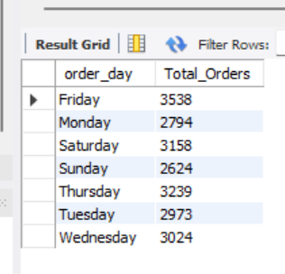

- Hourly Trend
select hour(order_time) as order_hour, count(distinct order_id) as Total_Orders
from sales
group by hour(order_time);
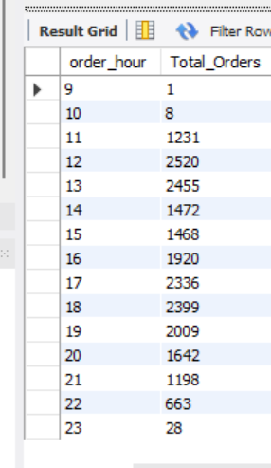

- Percentage of sales by pizza category
select pizza_category, sum(total_price) * 100 / (select sum(total_price) from sales) as pct_pizza_category
from sales
group by pizza_category;
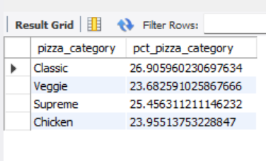

- Percentage of sales by pizza size
select pizza_size, round(sum(total_price) * 100 / (select sum(total_price) from sales),4) as pct_pizza_size
from sales
group by pizza_size
order by pct_pizza_size desc;
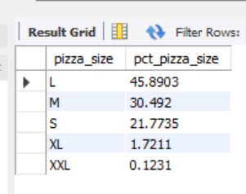

- Total pizzas sold by pizza category
select pizza_category, sum(quantity) as Total_pizza_Sold_Category
from sales
group by pizza_category;
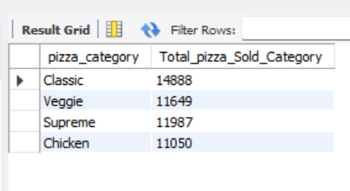

- Top 5 Best Sellers by Total pizzas sold
select pizza_name, sum(quantity) as Total_Pizza_Sold
from sales
group by pizza_name
order by Total_Pizza_Sold desc
limit 5;
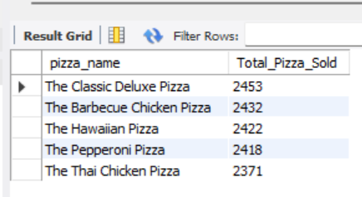

- Bottom 5 Worst Sellers by Total pizzas sold
select pizza_name, sum(quantity) as Total_Pizza_Sold
from sales
group by pizza_name
order by Total_Pizza_Sold
limit 5;
